Q31 A car covers the 1st half of the distance between two places at a speed of 20 km/h and the 2nd half at 30 km/h. What is the average speed of the car ?
- 25 km/h
- 24 km/h
- 26 km/h
- 27 km/h
Q32 The displacement time graph of a particle acted upon by a constant force is
- A straight line
- A circle
- A parabola
- Any curve depending upon initial conditions
Q33 A quantity has value of -12.0 m/s. It may be the :
a) Speed of a particle
b) Velocity of a particle
c) Position of a particle
d) Displacement of a particle
Q34 The velocity-time graph of a body moving in a straight line is shown in figure. The displacement travelled by the body in 6 seconds are respectively.
- 10m
- 12m
- 8m
- None of these
Q35 An object undergoes an acceleration of 8 m/s² starting from rest. Distance travelled in 1 s is :
- 2m
- 4m
- 6m
- 8m
Q36 If d denotes the distance covered by a car in time t sand s denotes the displacement by the car during the same time,then
Q37 A Light Year is a measure of
a) Light intensity
b) Time
c) Distance
d) None of the Above
Q38 An object is moving with uniform acceleration a. Its initial velocity is u and after time t its velocity is v. The equation of its motion is v = u+ at. The velocity (along y-axis) time (along x-axis) graph shall be a straight line
(a) passing through Origin
(b) with x-intercept u
(c) with y-intercept u
(d) with slope u
Q39 If two vectors and are at an angle ,then

Q40 When an object is thrown up, the force of gravity
a) is opposite to the direction of motion
b) is in the same direction as the direction of motion
c) decreases as it rises up
d) increases as it rises up
Q41 Consider the following velocity and time graph : [NDA -2018 II]
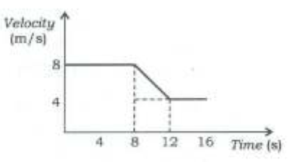
Which one of the following is the value of average acceleration from 8s to 12 s
- 8m/s²
- 12 m/s²
- 2m/s²
- -1m/s²

Q42 In figure BC represents a body moving :
a) Backward with uniform velocity
b) Forward with uniform velocity
c) Backward with non-uniform velocity
d) Forward with non-uniform velocity
Q43 If an object moves with constant velocity then which one of the following statements is NOT correct?
a) Its motion is along a straight line
b) Its speed changes with time ,
c) Its acceleration is zero
d) Its displacement increases linearly with time

Q44 The position time graph for motion of a body is given below
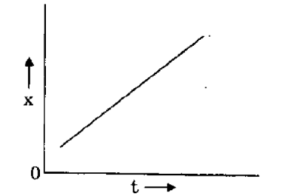
Which one among the following is depicted by the above graph.
- Positive acceleration
- Negative acceleration
- Zero acceleration
- None of the above
Q45 Dimension of impulse are
- [MLT⁻¹]
- [MLT²]
- [MT⁻²]
- [ML⁻¹T⁻³]
Q46 The following figure represents the velocity-time graph of a moving car on a road .Which segment of the graph represents the retardation?
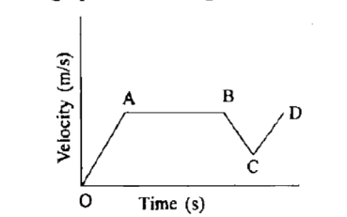
- AB
- BC
- CD
- None of these
Q47 Area between speed - time graph and time axis gives :
- Distance
- Velocity
- Speed
- None of these
Q48 Which of the following is not a vector ?
a) Speed
b) Velocity
c) Weight
d) Acceleration
Q49 From a building two balls A and B are thrown such that A is thrown upwards and B downwards (both
vertically). If v _{A} and v _{B} are their respective velocities on reaching the ground, then
a) v _{B} > v _{A}
b) v _{A} = v _{B}
c) v _{A} > v _{B}
d) None of these
Q50 The displacement of a particle at a time t is given by
where a ,b and c are positive constants,then the particle is
- accelerated along -direction
- decelerated along -direction
- decelerated along -direction
- accelerated along -direction

Q31 | Q32 | Q33 | Q34 | Q35
B | C | B | C | b
Q36 | Q37 | Q38 | Q39 | Q40
c | C | c | b | a
Q41 | Q42 | Q43 | Q44 | Q45
D | A | B | c | A
Q46 | Q47 | Q48 | Q49 | Q50
B | A | A | B | A

